Paper Prototype

Music Theory - The Basics

Michael S. Oberlin

June, 8 2014 - EDCI 56900 – Summer 2014

Purdue University

Table of Contents

Context, Learners, & Learning Objectives 2

Course Description 2

Target Learners 2

Intended Instruction 3

Learning Environment/Proposed Delivery Method 3

Learning Objectives 4

Instructional Content and Materials 4

Overview and Format 4

Home Page - Introduction 5

Lesson 1 - Taking Note of Music 6

Lesson 2 - Unlock The Song 7

Lesson 3 - It's About Time 9

Lesson 4 - Too Loud or Too Soft 11

Lesson 5 - Roll Over Beethoven - Compose Your Own Piece 12

Bonus Lesson - Solfège and Kodály 12

Assessment Tools 15

Resources 19

Directory Map 20

Storyboard 21

Merrill's 5 Star ID Rating System 25

References 29

# **Context, Learners, & Learning Objectives**

# **Course Description**

Many young students today enjoy singing, and based on their level of interest, some of them will choose to join a choir in school or in church. However, when given a piece of music from the conductor, they likely have very little experience reading music. Based on observations and participation of choir practices, in order for choir students to learn a piece of music they need to have the melody played for them as they sing to it at the same time. Further analysis also indicates that while most teachers agree that sight reading is a highly important skill, very few of them reveal they have a systematic way to address it (Hardy, 1998). There is a clear need to design a lesson to supplement the music programs of schools. Students of music will find it easier to learn and perform music if they have a better understanding of how to read it on their own, which will also lessen the burden on the teacher to have to play music on the piano for them so often. Enhancing sight reading enhances the primary reading skills of students as well. According to (Piro & Ortiz, 2009), a by-product of music training is learning to listen selectively, and thus may assist in both music and literacy. The main goal of the instruction within the e-learning module is to provide basic comprehension of the fundamentals of music theory and will be geared towards presentation for school music programs that include elective choir classes.

# **Target Learners**

The learners will consist of 6th, 7th and 8th graders who are in the beginning phase of singing in groups and different music parts, such as soprano/alto (higher to midrange notes for females) and tenor/bass (mid to low range notes for males). Upon observation most of students are comfortable singing on their own, however they are often challenged when combining with others for harmony. The e-learning module will prepare students through identification activities and repetitive practice to help them remain constant on the notes they read. Given the fundamental cooperative skills of this age group, many students will be able to practice this material in a group. However, the e-learning module is intended for individual learning as it is self-paced. Furthermore, this alleviates a majority of the concern for short attention spans since the student controls each lesson's length and how often they choose to use the module for review and practice. This module may be utilized by students with very little exposure to music theory as well as those with a strong background in reading music who can use it as a refresher course.

Another aspect of this module that cannot be overlooked is the individual motivation for students to participate. Many students who enjoy performing solo vocal pieces understand that auditions often require the performance of a solo piece. When opportunities for auditions come about, the person accompanying them on the piano for their trial is likely a perfect stranger and not a teacher they are familiar with, especially if the audition is for a production separate from school. The e-learning module has the potential to build confidence for these situations. For example, learners will be able to harness portions of what they have learned from the course and even practice while riding in the car on the way to the audition.

# **Intended Instruction**

Learners who participate in the e-learning module will already have some exposure to sheet music. However, they also acknowledge a lack of critical interpretation of what they have been presented in terms of note structure and symbols. The e-learning module will provide examples and concrete definitions of notes on a scale, time signatures, key signatures, dynamics and symbols as well as how they relate when placed in a musical theme. The module will allow practice of the basic skills in a virtual laboratory via the use of an online application called Noteflight ("Noteflight - Online Music Notation Software"). In order to form a connection to the content outside of sheet music, students will have the option of demonstrating the tones via Solfège (do-re-mi) using the Kodály Method (Choksy, 1999) and sign the tones with their hands, thus providing an alternative to vocal expression.

Most students are unable to sight-read effectively due to lack of individual guidance and insufficient instruction material (Hardy, 1998). Part of the goal of this lesson will be to fill the gap of individual learner attention through self-paced learner-led format, however some formative assessment is necessary based on the freeform evaluation that includes music composition. The instructor will manually review and grade the portion of the assessments that include music composition in Notflight. Summative assessment will be used for the material that requires tangible demonstration of understanding such as notes and rhythm identification.

# **Learning Environment/Proposed Delivery Method**

The e-learning module will be administered separate from the classroom environment and utilize Wordpress.com, an online web publishing platform ("About Us — WordPress.com", n.d.). Students will access the module via their personal computers or tablets and practice the musical techniques via Noteflight.com ("Noteflight - Online Music Notation Software"). Part of their formative assessment will take place on Noteflight as it allows students to share musical scores and the instructor can provide feedback. Peer initiated formative assessment will also take place on Noteflight's discussion boards. As previously stated, this format of instruction will supplement the systematic instruction teachers are unable to easily provide on an individual basis (Hardy, 1998). Assessments will be administered using surveymonkey.com ("SurveyMonkey: Free online survey software & questionnaire tool", n.d.).

# **Learning Objectives**

The following learning objectives, expressed following Mager's (1984) guidelines are as follows:

1. Given an onscreen musical scale of notes, students will be able to identify the letter names of the tonal notes given, and dictate them with few or no errors. (Revised by removing the specific reference to octave.)

2. When provided an onscreen represented key signature, students will be able to accurately recall from memory at least five (5) key signatures based on the number of sharps and flats they contain.

3. When provided a represented time signature, students will be able to specify and translate the corresponding rhythm at least five (5) time signatures with very few or no errors. (Revised to specify and translate time signature rhythm)

4. When provided a completed piece of music, students will be able to correctly label at least five (5) musical dynamic symbols and indicate their influence on the musical piece. (Revised to specify dynamic symbols.)

5. Given an open staff of sheet music, students will be able to compose a simple musical tune consisting of at least eight (8) measures of music, with few or no errors.

Bonus Lesson and Activity - Practical application will be integrated as an optional activity via hand signing tonal note identification, and express the tones via the Kodály Method (Choksy, 1999). (Revised from a sub-objective 1.1 to an independent lesson)

# **Instructional Content and Materials**

# **Overview and Format**

The instructional material will be presented via a simple navigation format using Wordpress. Each lesson for this e-module will have its own section, and assessments and helpful resources will be featured in the sub-section of each respective lesson. The lesson material will be presented on a single page which will include all needed text and corresponding images and examples in proportion to the specific elements being taught. This allows students to review material which is encapsulated in its own unit, detached from other material that may prove distracting. This is especially helpful if a certain student wishes to focus on remaining elements that they feel they have not yet mastered.

The following sections represent the text, images and resources of the content which will be supplied within the pages of the e-learning module. Each lesson is numbered based on pre-requisite material considered essential to progressing up the point of composition and creative practice. Please note that while the material is given in a subsequent order, students may likely already have a strong understanding of material covered in certain lessons, and therefore have the option to select any particular module they choose, depending on previous experience.

All pages on the website containing the e-learning module will have a top menu selection interface, thus allowing access to any page from any page. The numbering convention of the lessons will not specifically be titled as such in the actual Digital Prototype. They are indicated primarily for guided reference.

# **Home Page - Introduction**

Welcome to Music Theory - The Basics. This module will present some of the basic components of music theory, including:

* Musical Notes and Their Naming Convention
* Solfège (do-re-mi) Musical Scales
* Time Signatures
* Key Signatures
* Dynamic Symbols
* Music Composition

This module may be utilized by students with very little exposure to music theory as well as those with a strong background in reading music who can use it as a refresher course. You may choose to review any lesson in any order as you see fit. However, if you prefer to participate in every lesson available, please begin with the first lesson "Taking Note of Music." The lessons in order are as follows:

1. Taking Note of Music
2. Unlock The Song
3. It's About Time
4. Too Loud or Too Soft
5. Roll Over Beethoven

Bonus Activity: Solfège and Kodály

Each section will include a brief assessment to test you on what you have learned. If you miss too many of the questions, or feel unprepared for any activity, you may re-read any lesson and try again.

Good luck, and have fun exploring the building blocks of music theory!

# **Lesson 1 - Taking Note of Music**

When one listens to music, they likely do not imagine dots, lines and symbols in black and white on a piece of paper. However, in order for music to be interpreted by a conductor, musician or vocalist, they need to be represented in some fashion that can be readable. Just as words are written on paper or typed in a computer, musical notes are composed on a set of five horizontal lines known as a staff. Essentially, the staff consists of five lines and four spaces, where notes are placed. Depending on the instruments or vocal range associated with the musical piece they are divided into two levels known as clefs. There are two separate clefs where notes may appear in sheet music, the treble clef and the bass clef.

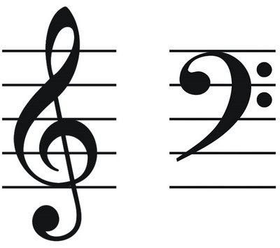The treble clef is where higher or brighter notes are composed, while the bass clef consists of lower rich tones. For the sake of simplicity and introduction, this lesson will focus only on the treble clef.

Notes in music are represented by a letter name from A to G. A full scale of notes actual consists of eight notes since the scale returns to the represented note of its foundation. In other words A, B, C, D, E, F, G with the eighth note completing and starting over with A. It is important to know however that even though the naming convention comes back to letter A after G, the tone is actually higher and does not mean the tone drops down to the first note of A in the scale. Any eight notes beginning respectively with a specific letter and returning to that letter up or down, make up a group of notes called an octave. The "oct" being derived for the Latin word "octo" meaning eight.

Figure 1 : Treble Clef (left), Bass Clef (right) - Retrieved from: http://www.clipartbest.com/clipart-4T9L8EXTE

The short alphabetized order appear in an ascending fashion from bottom to top of the staff. The notes on the treble clef can be remembered by using a simple word and a phrase. The notes on the spaces from bottom to top are designated as F, A, C, E, or “FACE.” The notes on the lines are designated as E, G, B, D, F, which can be remembered by the phrase “Every Good Boy Does Fine.” You can also come up with other phrases that may help you remember, such as “Every Good Boy Deserves Fudge.”

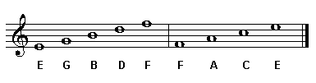

Figure 2 : Notes of the Treble Clef - Retrieved from: http://www.teoria.com/reference/media/img/read_07a.gif

# **Lesson 2 - Unlock The Song**

A device known as a key signature is used to indicate what particular notes are to be played either higher or lower in a given song. While basic music follows a convention of a simple scale, songs with varying tones may be written with specific keys in order to represent these specialized tones. The tones for the particular key signatures are represented using symbols known as sharps, for notes to be played slightly higher than usual; and flats, for notes to be played slightly lower than usual. Key signatures can be labeled as major or minor, depending on overall composition. However, for the sake of simplicity, we will focus primarily on the major key signatures.

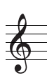

Figure 7: Key of C Major - Retrieved from https://www.basicmusictheory.com/img/c-major-scale-on-treble-clef.png

The above example represents a song in the basic key of C Major that contains no sharps or flats. When additional sharps and flats are added to the key signature changes depending on the amount of sharps or flats indicated.

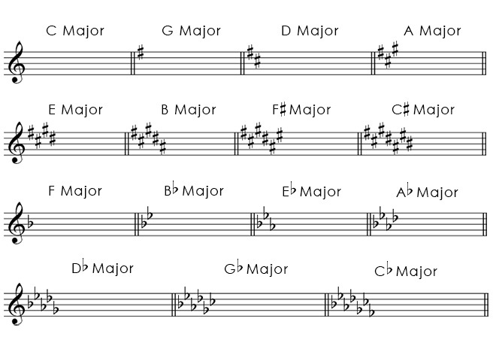

Figure 8: Major Key Signatures - Retrieved from http://fundamentalsofmusic.com/images-melody/major-key-signatures-treble-clef.jpg

The key signatures above show that a maximum of seven sharps or seven flats can be used. As previously mentioned, every note space where they are placed means that particular note is played higher or lower in the given piece.

Listen to the sound of each of the following examples of notes played in two different key signatures. The first is C major, the second is E major.

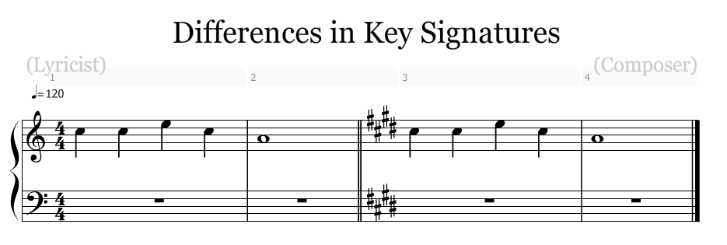

Figure 9: Key Signature Sound Differences - Retrieved from http://www.noteflight.com/scores/view/f38404e2f1c0e3a0dec9409e488f005d4bd04fe9

(Note: A Link will be embedded for the Digital Prototype so the example can be played via the webpage.)

Notice that even though the same notes are marked, they sound differently? This is specifically what the key signature's purpose is and how it shapes the way music is composed in order to interpret how a song is to be performed.

One of the easiest ways to identify a key signature is to simply look at a particular sharp or flat in the key signature. Just as we can identify the key of C major by the fact it has no sharps or flats, we can look at key signature of sharps and note that the key signature is the note that is just above the last sharp depicted.

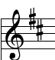

Figure 10: Key of D Major - Retrieved from noteflight.com

In the example above, the last sharp is placed on C. One note above C being D, indicates that that the key signature D major.

Key signatures featuring flats are identified a bit differently than those including sharps. In the case of flats, simply take second to last flat that appears in the key signature. The second to last note depicts the key signature.

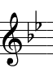

Figure 11: Key of B flat major - Retrieved from noteflight.com

In the example above the second to last flat is placed on the B. Therefore, this indicates the key signature is B flat major. Please note that when only one flat is depicted, this indicates that the key signature is F major. This can be remembered by using the phrase "One F for Flat."

# **Lesson 3 - It's About Time**

"Unlock the Song" introduced us to key signatures, however this is not the only element that is used to determine the aspects of a musical piece. An essential part of music composition is rhythm. Every note in a particular piece of music carries a value of time represented by a fraction. A measure, or bar, is a segment of the music that dictates the meter and pace of the music. A fraction is used to represent the length of time a note should be sung or performed within a measure. The rate at which notes are played is specifically based on what is known as a time signature. A time signature is represented by two numbers on the staff just after the treble clef at the very beginning of a musical piece.

For instance, the top number in a time signature indicates the number of counts or beats which are to be played in each measure. The bottom number indicates which particular note equals one beat.

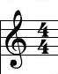

Figure 3: 4/4 Time Signature - Retrieved from noteflight.com

In the example above representing the time signature 4/4, there are to be four (4) beats per measure where a quarter note (represented by the bottom number 4) equals one count. The most common notes are indicated in the following diagram:

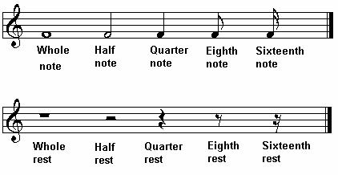

The values of the notes are changed based on the change in numbers in the time signature.

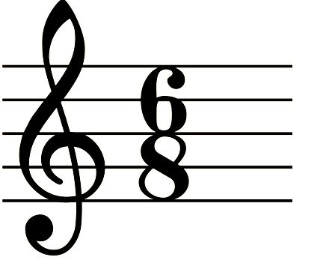

Figure 5: 6/8 Time Signature - Retrieved from http://2.bp.blogspot.com/-7eb2ucO5ia8/T8sw2yoFlSI/AAAAAAAAADQ/lUUMCFUYk2E/s1600/6.8.JPG

The example above represents the time signature 6/8, where there are to be six (6) beats per measure and an eighth note (represented by the bottom number 8) equals one count.

Take a look at the following examples of other time signatures remembering that the top number is the number of beats per measure, and the bottom number is the type of note that receives one beat of playing time.

# 

Figure 6: Other Time Signatures - Retrieved from http://blog.kennedyviolins.com/wp-content/uploads/2012/11/Common-Time-Signatures.jpg

# Lesson 4 - Too Loud or Too Soft

There is more to the note than just the sound or the tone it represents. Music can be played or sung at varying levels of volume and in music there is a simple system for indicating how loud or soft music should be performed. In music theory these indications are known as dynamics. Dynamics are represented primarily by the letter symbols; F and P. These letters stand for Italian music terms; forte meaning loud, and piano meaning soft.

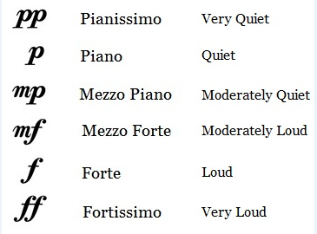

Figure 12: Dynamics and Their Meanings - Retrieved from: http://3.bp.blogspot.com/-sFHvaHxThP8/URh5UaLf-GI/AAAAAAAAABM/Q6vWDOFJtlI/s1600/alldynamics2.jpg

When these specific symbols appear below the staff in a piece of music, they indicate that the specific notes in a given section should be played at the respective volume, loud or soft. Dynamics however can also indicate to what degree of volume the notes may be played. For instance, if you wish for a part to be moderately loud, you would indicate this with the letters "mf" which stands for mezzo forte. In the same fashion, you could have a part be moderately soft by indicating the letters "mp" which stands for mezzo piano. Therefore, volume can be played to multiple levels instead of simply loud or soft.

Another form of dynamics can be used to indicate that a transition from a degree of volume can occur. This is done by using symbols know as crescendo, meaning gradually louder and decrescendo, meaning gradually softer. This allows for parts of the piece to build or diminish in volume between specific sections and can be used to accentuate a grand or subtle part of the song.

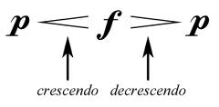

Figure 13: Crescendo and Decrescendo - Retrieved from http://www.themeandvariations.org/Images/notation/dynamics.png

# Lesson 5 - Roll Over Beethoven - Compose Your Own Piece

Now it's your turn to create a piece of music based on what you have learned. Noteflight.com is a free online music application that allows you to create and share original pieces of music. Please follow the following steps:

1. Access noteflight.com at the following link <http://www.noteflight.com>.
2. Sign up for a free account.
3. Review the first online tutorial which explains the basic functions of placing notes of varying lengths, rests etc.
4. You have the option to either share your musical piece with the rest of the community or embed it in your own website.

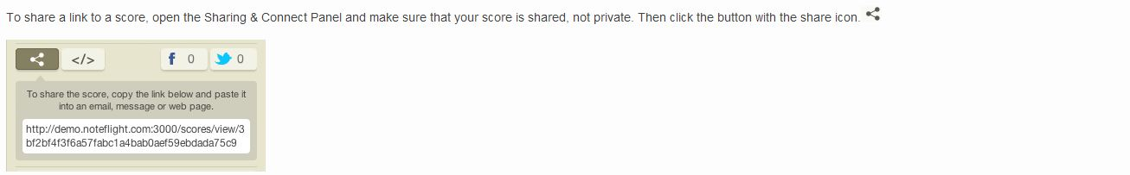

To learn more about online sharing and the use of noteflight.com, visit <http://www.noteflight.com/guide>.

# Bonus Lesson - Solfège and Kodály

One of the most common instruments played, especially when teaching music, is the piano. The piano is capable of producing 88 individual tones, representing nearly all of the playable tones used in music composition. However a piano may not always be available for reference to notes. This is especially true with vocalists, where your instrument is you voice itself and the tones must be voluntarily sung in order to be heard. How can one reference tones and notes in the absence of a piano? Musical tones can be sung and represented via a method called Solfège, an essential singing exercise using sol-fa syllables ("Solfège - Definition and More from the Free Merriam-Webster Dictionary", n.d.). Similar to the standard letter named convention of music, A, B, C, D, E, F, G, the sol-fa syllables are indicated as Do, Re, Mi, Fa, Sol, La, Ti (returning to Do for the beginning of the next octave).

The reciting of Solfège can be further represented via hand signals. A Hungarian composer named Zoltán Kodály, helped to develop a method of using hand signals to represent the individual syllables (Choksy, 1999). Depending on the key of a specific piece of music, any note can be signed using hand signals, thus allowing a reference to music without producing a sound. The Kodály Method appeared in the popular science fiction film *Close Encounters of the Third Kind* (Spielberg, 1977). The following clip gives an example of how the hand signals may be used when incorporated with individual tones. Pay particular attention the character on the left side of the screen at 0:15.

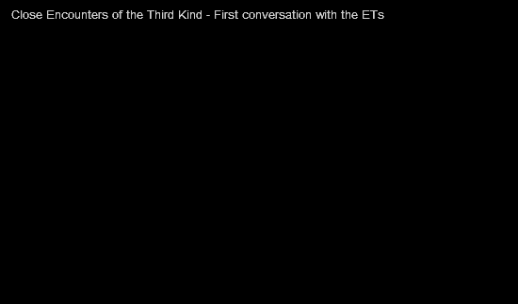

<http://youtu.be/AphKxQ2NsQo>

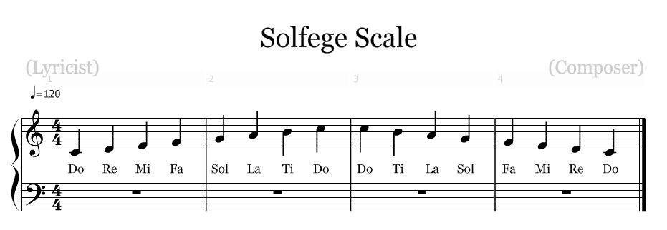

Figure 14: Solfège Scale - Retrieved from noteflight.com

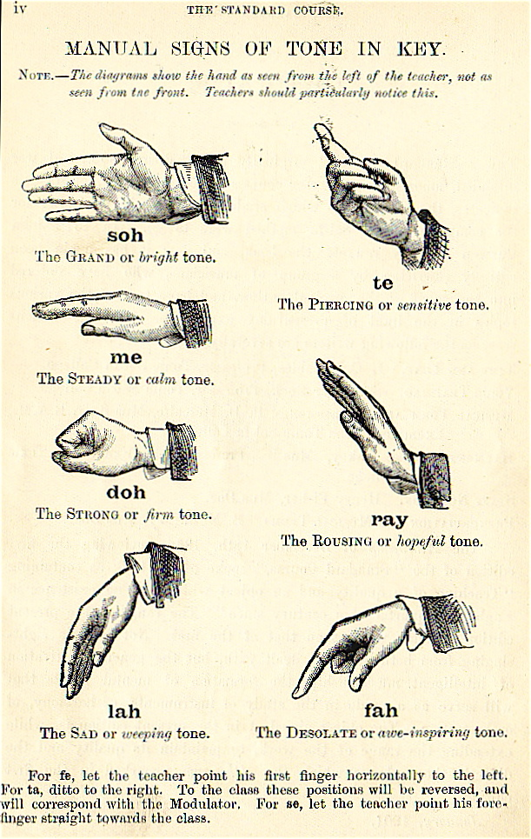

Figure 15: Kodály Hand Signs - Retrieved from http://en.wikipedia.org/wiki/Kod%C3%A1ly_Method#mediaviewer/File:Curwen_Hand_Signs_MT.jpg

Practice the hand signals using the Solfège Scale, from bottom to top and back to the bottom. See if you can sign out a simple song using just the hand signals.

# Assessment Tools

As previously mentioned, summative assessments will be administered using surveymonkey.com ("SurveyMonkey: Free online survey software & questionnaire tool", n.d.). This will apply primarily for assessments 1-4, specifically because the evaluation for objective 5 will be completed using a composition activity through noteflight.com.

Assessment 1

1. Given an on-screen musical scale of notes, students will be able to identify the letter names of the tonal notes given, and indicate them with few or no errors.

Upon completion of instruction, the assessment will evaluate the student's ability to identify notes when presented with an on-screen piece of music with few or no errors.

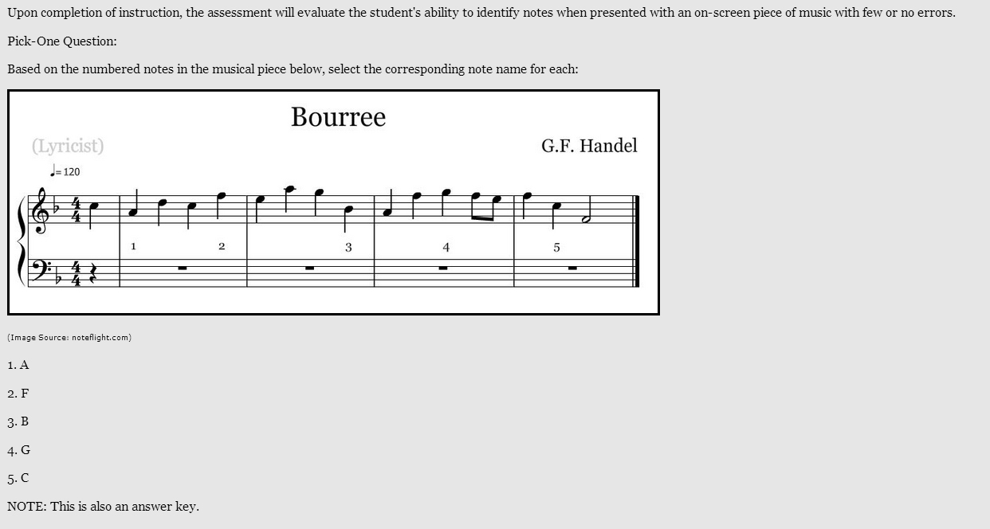

Assessment 2

When provided an on-screen represented key signature, students will be able to accurately recall from memory at least five (5) key signatures based on the number of sharps and flats they contain. Upon completion of instruction, the assessment will evaluate the student's ability to identify key signatures given an on-screen representation with few or no errors.

Matching-list Questions:

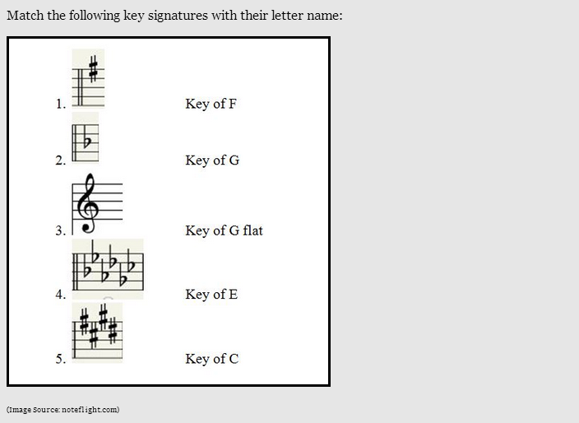

Answer Key:

1. Key of G

2. Key of F

3. Key of C

4. Key of G flat

5. Key of E

Assessment 3

When provided a represented time signature, students will be able to specify and translate the corresponding rhythm with very few or no errors. (Revised to specify and translate time signature rhythm)

Fill in the blanks questions:

Based on the following images, please indicate the time signature and its corresponding rhythm.

1. 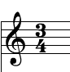

2. 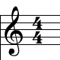

3. 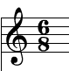

4. 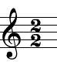

5. 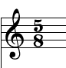

Answer Key: 1. 3/4, Three beats per measure, a quarter note is one count. 2. 4/4, Four beats per measure, a quarter note is one count. 3. 6/8, Six beats per measure, an eighth note is one count. 4. 2/2, Two beats per measure, a half note is one count. 5. 5/8, Five beats per measure, an eighth note is one count. (All images retrieved from noteflight.com)

Assessment 4

When provided a completed piece of music, students will be able to correctly label at least five (5) musical dynamic symbols and indicate their influence on the musical piece. (Revised to specify dynamic symbols.)

Fill in the blanks questions:

Based on the following images, please indicate the time name of the dynamic mark and the effect it indicates on music.

1. 

2. 

3. 

4. 

5. 

Answer Key: 1. forte - loud 2. pianissimo - very quiet 3. mezzo forte - moderately loud. 4. fortissimo - very loud. 5. crescendo - gradually louder. (All images retrieved from noteflight.com)

Assessment 5

Given an open staff of sheet music, students will be able to compose a simple musical tune consisting of at least eight (8) measures of music, with few or no errors.

Using noteflight.com, compose your own piece of music consisting of no fewer than eight (8) measures. Choose one key signature and one time signature. You must use a minimum of three (3) note types, two (2) rest types, and two (2) dynamic marks. Once complete, share your piece within noteflight.com social media for evaluation.

Have fun with your piece and be creative. Look to form musical patterns and make it your own.

# Resources

Please visit the following website from emusictheory.com for more information on music theory as well as other activities.

<http://www.emusictheory.com/learning.html>

# **Directory Map**

(NOTE: All pages on the website containing the e-learning module will have a top menu selection interface, thus allowing access to any page from any page. The numbering convention of the lessons will not specifically be titled as such in the actual Digital Prototype. They are indicated primarily for guided reference.)

# Storyboard

Each of the following screen shots represent the types of pages including lesson pages and assessment pages on the e-learning module web page. This is only a preliminary layout and will likely change with the Digital Prototype.

Home Page

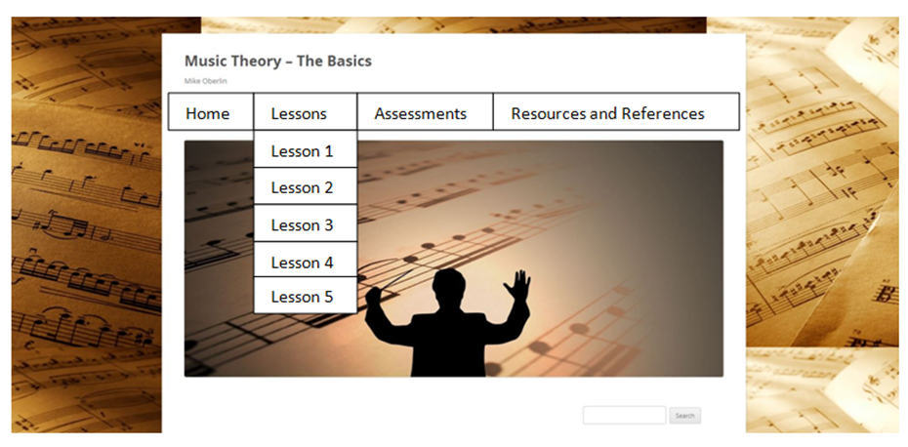

Main Home Page will feature tabs with dropdowns for corresponding lessons and assessments. Background will be locked - Images retrieved from http://www.vistarproductions.com/images/composition%20background%20flatten.jpg, http://www.familylifeministry.atlanta.goarch.org/wp-content/uploads/2013/01/sheet-music-small.jpeg

Lesson Page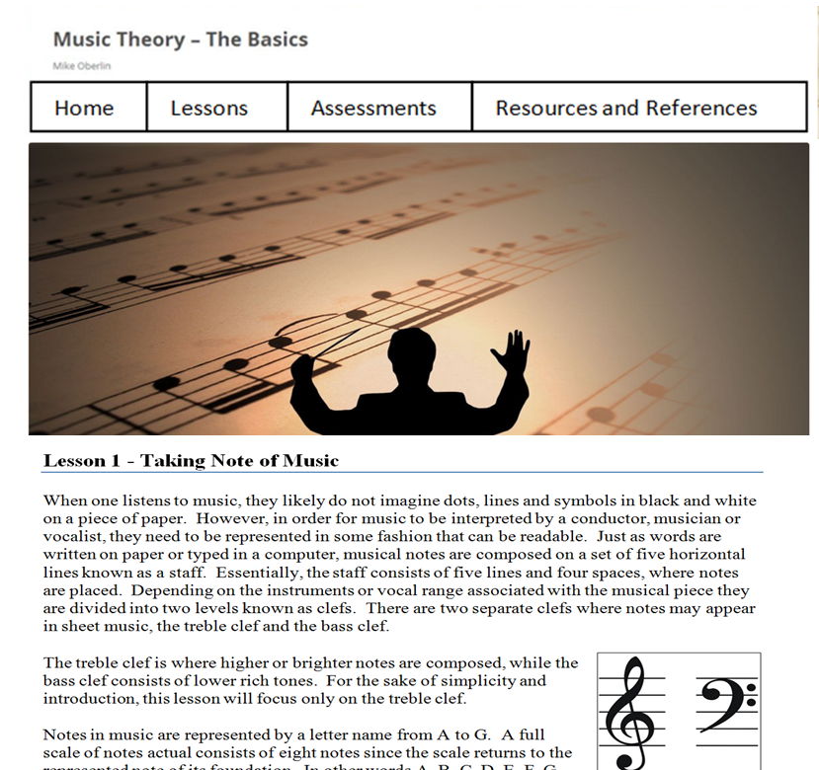

Lesson Page will be framed for a locked scrolling, while the menu and main image will remain stationary.

Assessment Page

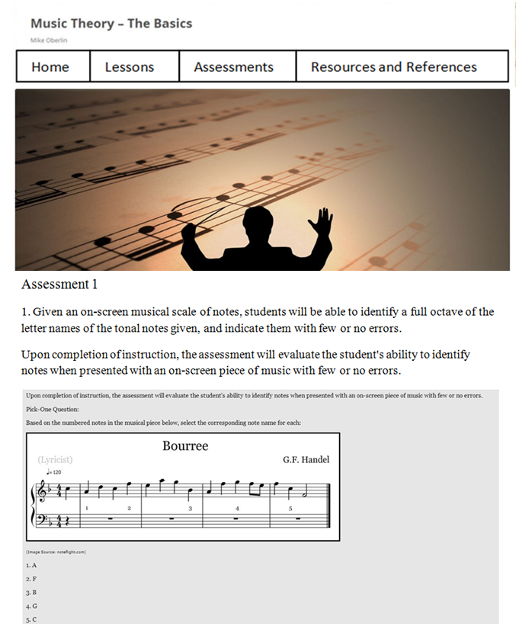

Assessment Pages will be framed for a locked scrolling, while the menu and main image will remain stationary. Surveymonkey.com questions will be embedded within page.

Resources and References Page

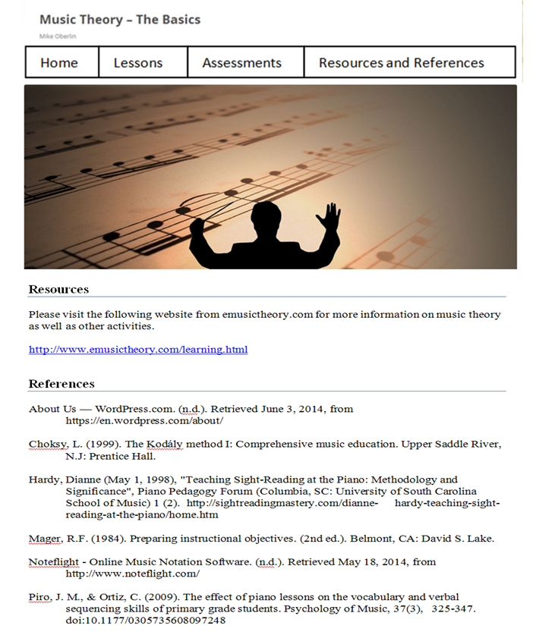

Resources and References Page will be framed for a locked scrolling, while the menu and main image will remain stationary.

# Merrill's 5 Star ID Rating System

| Stage | Criteria | Explanation | |
| --- | --- | --- | --- |
| Rating for Problem Stage: | | | |
| Is the courseware presented in the context of real world problems? | Does the courseware show Learners the task they will be able to do or the problem they will be able to solve as a result of completing a module or course? | | Yes. Learners are not only aware of what they will be able to do, but also are exposed to the specific details of the individual components of each lesson. This gives them a foundation as to why certain information is necessary when applied in their own practice of music.  Yes. Learners are able to directly utilize every aspect of the material presented and will be able to formulate their own representation of the material via composing music.  Yes. The lessons in the module are presented in an order suitable to progressive learning, as some foundational lessons must be completed first. |
| Are students engaged at the problem or task level not just the operation or action levels? | |
| Does the courseware involve a progression of problems rather than a single problem? | |
| Rating for Activation Stage: | | | |
| Does the courseware attempt to activate relevant prior knowledge or experience? | Do the courseware direct Learners to recall, relate, describe, or apply knowledge from relevant, past experience that can be used as a foundation for new knowledge? | Yes. The courseware recognizes that some of the learners may already have acquired some of the knowledge of the material presented.  Yes. It establishes itself as a module to lay a foundation of new knowledge.  Yes. Each lesson has an assessment or evaluation activity directly associated with the respective lesson, thus allowing the learner to select specific lessons as they see fit. | |
| Does the courseware provide relevant experience that can be used as a foundation for the new knowledge? |
| If Learners already know some of the content are they given an opportunity to demonstrate their previously acquired knowledge or skill? |
| Rating for Demonstration Stage: | | | |
| Are the demonstrations (examples) consistent with the content being taught? | Are the demonstrations (examples) consistent with the content being taught?   * Examples and non-examples for concepts? * Demonstrations for procedures? * Visualizations for processes? * Modeling for behavior? | Yes. Images representing the musical elements and terms are directly related to their explanations. Noteflight.com allows the students to compose music digitally, thus giving the element of a virtual laboratory for composing music.  Yes. Not only are learners given specific references within the lessons, they are also given comparisons and tips as a method to better retain the knowledge transferred. Offsite resources and examples are also provided to provide multiple perspectives of how the musical content is presented by other educators. | |
| Are at least some of the following Learner guidance techniques employed?   * Learners are directed to relevant information? * Multiple representations are used for the demonstrations? * Multiple demonstrations are explicitly compared? |
| Is media relevant to the content and used to enhance learning? | Yes. Noteflight.com is an integral part in the composition activities, and specifically presents the learners with an opportunity to be creative. | |
| Rating for Application Stage: | | | |
| Are the application (practice) and the posttest consistent with the stated or implied objectives? | Are the application (practice) and the posttest consistent with the stated or implied objectives?   * Information-about practice requires Learners to recall or recognize information. * Parts-of practice requires the Learners to locate, name, and/or describe each part. * Kinds-of practice requires Learners to identify new examples of each kind. * How-to practice requires Learners to do the procedure. * What-happens practice requires Learners to predict a consequence of a process given conditions, or to find faulted conditions given an unexpected consequence. | Yes. The stated objective, verb and condition are all directly represented in each activity. The images provide consistency in the application and the post tests. There is very little ambiguity between the musical terms and symbols and the way the knowledge transfer is presented. Learners may relate their mathematical skills to the lessons such as meter and time signatures, thus giving a connection to consequences of incorrect equations and number combinations are produced.  Yes. For the composition activities, learners will be provided with formative feedback from the instructor as these portions must be evaluated manually. Any and all new knowledge can be used in the music composition activities.  Somewhat. Noteflight.com allows students to share their individual works with other participating students, however there are no automated prompts regarding misinterpretation of material. Because the module is considered to be supplemental, coaching does not play a major role in the lessons and activities. | |
| Does the courseware require Learners to use new knowledge or skill to solve a varied sequence of problems and do Learners receive corrective feedback on their performance? |
| In most application or practice activities, are Learners able to access context sensitive help or guidance when having difficulty with the instructional materials? Is this coaching gradually diminished as the instruction progresses? |
| Rating for Integration Stage: | | | |
| Does the courseware provide techniques that encourage Learners to integrate (transfer) the new knowledge or skill into their everyday life? | Does the courseware provide an opportunity for Learners to publicly demonstrate their new knowledge or skill? | Yes. Students are given an opportunity to create their own music and share and embed their works in web format. This aspect provides encouragement as students enthusiastic and proud of their creativity are more likely to share their experience and knowledge. | |
| Does the courseware provide an opportunity for Learners to reflect-on, discuss, and defend their new knowledge or skill? |
| Does the courseware provide an opportunity for Learners to create, invent, or explore new and personal ways to use their new knowledge or skill? |

# References

About Us — WordPress.com. (n.d.). Retrieved June 3, 2014, from https://en.wordpress.com/about/

Choksy, L. (1999). The Kodály method I: Comprehensive music education. Upper Saddle River, N.J: Prentice Hall.

Hardy, Dianne (May 1, 1998), "Teaching Sight-Reading at the Piano: Methodology and Significance", Piano Pedagogy Forum (Columbia, SC: University of South Carolina School of Music) 1 (2). http://sightreadingmastery.com/dianne- hardy-teaching-sight-reading-at-the-piano/home.htm

learning: eMusicTheory.com. (n.d.). Retrieved June 8, 2014, from http://www.emusictheory.com/learning.html

Mager, R.F. (1984). Preparing instructional objectives. (2nd ed.). Belmont, CA: David S. Lake.

Noteflight - Online Music Notation Software. (n.d.). Retrieved May 18, 2014, from http://www.noteflight.com/

Piro, J. M., & Ortiz, C. (2009). The effect of piano lessons on the vocabulary and verbal sequencing skills of primary grade students. Psychology of Music, 37(3), 325-347. doi:10.1177/0305735608097248

Solfège - Definition and More from the Free Merriam-Webster Dictionary. (n.d.). Retrieved from http://www.merriam-webster.com/dictionary/solfege

Spielberg, S. (Director). (1977). Close Encounters of the Third Kind [Motion picture]. United States: Columbia Pictures.

SurveyMonkey: Free online survey software & questionnaire tool. (n.d.). Retrieved June 3, 2014, from https://www.surveymonkey.com/