Assignment 1: Performance Analysis

Michael S. Oberlin

July 20, 2014 - EDCI 52800 – Summer 2014

Purdue University

**Super Century Insurance Company**

The insurance industry in the United States provides millions of people with insurance coverage on a daily basis, and with so many individual products and a wide customer base, the service of these policies is essential to an insurance company's continued success. The Super Century Insurance Company is no exception. Super Century primarily sells and administers health and life insurance policies as well as annuities. The company also manages a wide array of workforce and group policies that are associated with small businesses. Like other insurance companies, Super Century must adhere to strict external guidelines not only influenced by the National Association of Insurance Commissioners (NAIC) but also the individual state Departments of Insurance (DOI) in which they do business. Super Century is also a public company subject to high shareholder expectations and therefore must carefully preserve their reputation in the markets. Additionally, Super Century is subject to the rating systems of other financial institutions where it is imperative to maintain a high rating in order to sustain marketability. The company relies heavily on a large network of agents and sales distribution networks as well. The requests made by these agents on behalf of their clients and the prompt payment of commissions to successful sales representatives are essential to maintaining a satisfied independent sales force that collects premiums to support company revenue. These are just some of the many influences of the external environment.

With such a plethora of policies to administer, a variety of policy types, changing business practices, and regulatory requirements to adhere to, it is no surprise that several obstacles present themselves on a regular basis. The following performance analysis looks particularly into the communication challenges of the customer correspondence operations and the delegation of these responsibilities to the company's contracted offshore vendor.

**The Performance System**

The human performance system of the company has recently been recognized as an area in need of improvement specifically in the area of policy administration. Transactions such as premium application, beneficiary changes, coverage adjustments as well as customer correspondence are handled by a department in New Delhi India. All of the previously discussed external environmental influences that apply to the domestic operations in the United States, also apply to the performance expectations of the offshore processing vendor in India. It is important to note however, that the internal environmental factors are what have the most influence on the behaviors of the offshore personnel themselves.

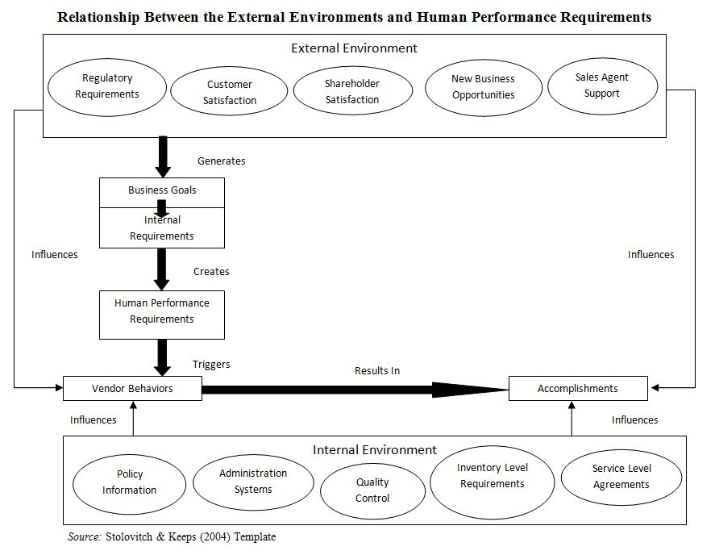

**Drivers of the Performance Gaps**

The task of customer correspondence encompasses responding to both general and policy specific customer inquiries that are received via email and the traditional post office letter medium. After Super Century successfully migrated premium application and simple policy accounting measures to the offshore vendor, upper management began to consider transferring other processes as well. Because of the cultural differences and language barrier there was initial hesitation to allow the offshore associates to respond directly to customers. However, several canned response letters existed and several of these letters were being sent for general responses to other transactions, such as change confirmations and billing application notices. One major difference between these transactions and general correspondence is that the canned letters already possess several pre-determined variables to choose from to address common situations. This is not the case for situations that call for a detailed and unique response. Even with the canned responses already available, the offshore team eventually reached a point where there was a need to use free form letters that allow an open response the customer. As previously stated however, language barriers, lack of specific policy knowledge and several other factors led to responses generated by offshore representatives that delivered inaccurate and even misleading information. Upper management recognizes that all of the necessary training was executed before representatives in India were allowed to proceed, but much of this training was implemented in the same way it was to onshore representatives who possess English as their first language. Several resources including American terminology including business writing guidelines were provided. Even with these tools available, the lack of policy specific knowledge across all offshore representatives was inconsistent. This along with a high turnover rate greatly contributed to the problems generated by allowing free form responses to customers by the offshore vendor associates. Needless to say, the letters that were sent with incorrect information and even grammar errors required additional apology letters to reconcile the incorrectly relayed information. This also lead to a higher inventory, as newer incoming requests could not be addressed at the regular rate that aligned with the company's internally designated Service Level Agreements (SLA). Quality control also recognized these inaccuracies and began to designate fail status on the randomly selected audited letters. This greatly discourages the offshore vendors from processing regular correspondence that requires a freeform response, thus they often resorted to a canned response that does not provide the requested information. This also led to an increase in questions relayed to the onshore team on what verbiage to use and what correct policy information should be provided. The following chart describes the performance gaps, desired state, actual state, assumed root causes and type of performance block in accordance with Gilbert's Behavioral Engineering Model, or BEM (Stolovitch & Keeps, 2004).

**Performance Gap Details**

|  |  |  |  |  |
| --- | --- | --- | --- | --- |
| **Performance Gap: Description** | **Desired State** | **Actual State** | **Probable root cause(s)** | **Type (Gilbert’s BEM)** |
| Inadequately written free form customer response letters | 97% quality rating, based on monthly performance of letters audited by quality control | 60% quality rating, based on monthly performance of letters audited by quality control | Knowledge - English is not the primary language of offshore associates Resources – Offshore associates resort to free form letters due to lack of sufficient existing canned letters | Knowledge, Resources |
| Increased inventory to process. Regular processing is discouraged and therefore Service Level Agreements are not met | Less than 50 responses pending completion daily.  Inbound requests must be acknowledged for processing within 2 days of receipt of work | Over 100 responses pending completion daily.  Inbound requests are acknowledged over 5 days of receipt of work | Information - Offshore representatives are not as aware of outstanding inventory and the length of time it is outstanding.  Consequences - Offshore representatives are hesitant to process due to excessive failed work via audit | Information, Consequences |
| Increased questions relayed to onshore representatives requesting clarification on policy coverage details and policy language | Less than 5 daily email inquiries to domestic SMEs requesting clarification on policy coverage details and policy language | Over 25 daily email inquiries to domestic SMEs requesting clarification on policy coverage details and policy language | Knowledge - Offshore representatives are not aware of the broad details of policy benefits.  Capacity - Several offshore representatives are not able to dictate policy benefits in an open ended manner and prefer closed ended responses | Knowledge, Capacity |

*Source:* Stolovitch & Keeps (2004) Template

**Continued Investigation**

With clear and measurable performance gaps identified, further investigation may be conducted to acquire detailed information on the possible root causes in anticipation of plausible future solutions. Possibly the most evident performance block is based on the different cultures involved. Not only is the language barrier a troublesome obstacle, but the open ended responses demanded by customer correspondence accentuates this to an even higher degree. As, previously stated, processes that the company migrated before correspondence were close-ended (black and white). However, the ability to provide an open-ended answer (gray) to an extremely specific question posed by a customer who already lacks considerable understanding of their own policy, is not something that every individual is capable of, let alone comfortable performing.

Even with the separate culture involved, the offshore associates must make every effort to strive for customer satisfaction. With management receiving feedback from the customer based on the output (Addison & Wittkuhn, 2001), it is recognized that more than several tools should be utilized to promote effective investigation. It should not be overlooked, however, that the offshore vendors themselves can provide valuable information to target the specific troublesome factors. While recognition of the hindrances caused by diverse approaches in the workplace can help identify performance gaps, harnessing the benefits of the diversity can help provide solutions. For instance, as Marques (2007) indicates "an organization that makes itself a hearth of diversity will be able to come up with a multiplicity of original approaches." The following chart presents tools and techniques that may assist in the investigative process.

**Investigative Tools**

|  |  |  |
| --- | --- | --- |
| **Performance gap: Description** | **Technique/tool for further investigation** | **What you hope to learn** |
| Inadequately written free form customer correspondence response letters | Existing data analysis | By reviewing examples of poorly written letters, we can target what content and specific verbiage that presents the greatest challenges to the offshore representatives. If specific patterns are recognized, we can also deduce if the verbiage problems are associated with all correspondence processors or individual instances. |
| Increased inventory to process. Regular processing is discouraged and therefore Service Level Agreements are not met | Documentation Analysis | By reviewing existing canned letters we can determine what scenarios are already covered, and whether or not the correspondence processors are aware of these letters. Additionally, we can review the documented standards of quality in order to determine what parameters consist of an accurate letter than answers the customer's inquiry. |
| Increased questions relayed to onshore representatives requesting clarification on policy coverage details and policy language | Surveys and Questionnaires | Question both the offshore correspondence processors as well as the onshore SMEs to determine the most common questions received, in order to isolate and categorize any regularly encountered difficult policy subject. |

*Source:* Stolovitch & Keeps (2004) Template

**Conclusion**

It is important to note that while several performance gaps have been identified, the potential root causes, investigative tools and desired return feedback from said investigations are by no means exhaustive. It is extremely likely that as documentation analysis proceeds, further regulatory requirements may be encountered that could restrict any immediate changes. Additionally, interdepartmental influences can arise from even subtle changes in protocol, and therefore increased awareness of this fact is essential to keep in mind during each step of the investigative process and before assuming any outright solutions. In this same manner, it is quite possible that more manageable interventions may be applied to decrease and even eliminate performance gaps (Stolovitch & Keeps, 2004). Overall, the process will be supported by any means necessary using the current resources and any new information obtained along the way. The team will be receptive to any criticism, suggestions and demands made on behalf of the company to ensure that the problems are solved.

**References:**

Addison, R. M., & Wittkuhn, K. D. (2001). HPT: The culture factor. Performance Improvement, 40(3), 14-19.

Marques, J. (2007). Implementing workplace diversity and values: What it means, what it brings. Performance Improvement, 46(9), 5-7. doi:10.1002/pfi.159

Stolovitch, H.D., & Keeps, E.J. (2004). Training Ain’t Performance. Alexandria, VA: ASTD Press.