Learning Styles and Multimedia

Michael S. Oberlin

Purdue University

EDCI 513 – Fall 2013

Abstract

Of the various learning styles, it seems natural to associate visual learning with multimedia instruction. However, it is also important to determine if better and richer visuals are better for learning overall. Instructors must also consider how rich media relates with a student’s ability to learn and if we are heading towards sensory overload in terms of instruction. A case may be made that there is insufficient evidence that identifying a student's preferred learning style will lead to a better outcome (Pashler, 2008). Students may benefit most from mixed presentations using both auditory and visual techniques (Coffield et al., 2004). With this in mind, learning using rich media should be relied upon as a supplement to instruction and cannot fully replace the guidance of a mentor. This paper will explore how Multimedia Learning Design relates to individual learning styles, examples of its instructional advantages and disadvantages and how a mix of perspectives may be essential to comprehensive learning.

**Introduction**

In today’s world of progressing technology, it was only a matter of time that multimedia found its way into the classroom. Direct instruction is no longer limited to the chalkboard and students are utilizing more advanced programs in modern educational environments. Much similar to the expansion of instructional films presented to soldiers during World War II, multimedia has once again become a relevant tool for training and educating. The wider availability of computers, the Internet and mobile devices has literally put an interactive lesson in the palm of the student’s hand. Portability and faster internet speeds allow classrooms to be carried around in a light-weight slim tablet. Material and instruction can be delivered via video, music, narration and even through video games making the case that the use of multimedia in curriculum design can produce a more appealing learning experience. However, the constant motivation to integrate technology into everyday life places pressure on the field of instructional design. When it comes to education, it may not always be best to use technology just for the sake of technology being available.

**Types of Educational Multimedia**

One of the earlier forms of multimedia that was introduced for educational purposes was the film strip. During the 2nd World War, soldiers were trained through the extensive use of film education which included motion pictures and slide projectors. This allowed not only for U.S. Army and industry personnel to be trained faster, but also discouraged absenteeism as the learner found films to be more appealing and more interesting than regular training programs (Reiser, 2012). This paved the way for films to be utilized in civilian industry and the classroom after the war. More films covering an array of subjects were produced and an instructor would only need to know how to set up a projector to implement the presentation.

As technology continued to evolve, the use of film began to be replaced by video cassettes and throughout the 1980s video tapes became more prevalent in classrooms. Unlike films and projection equipment video cassettes are lightweight, more portable, more easily stored and could be setup to play within seconds rather than minutes (Ornstein, 1991). In addition to the ability for easy playback, video cassettes could record live television programs including interviews, seminars, special events and even the student’s projects themselves with the use of a camera (Ornstein, 1991, p.38).

Integrated classroom programs were also produced during the 1980s. Bank Street College produced *The Voyage of the MIMI* in 1984 which also starred a young Ben Affleck. The 13 part television series was a classroom integrated program that followed a crew of shipmates on an oceanic science investigation and included a book, software and teachers guide (Gibbon, 1986). The program was well received by students and motivated them in the fields of science and mathematics, however teachers found it difficult to associate the program with their traditional class concepts (Gibbon, 1986). While seductive details that are incorporated into lessons can be associated with a general topic, they may sometimes be irrelevant to the overall instructional goal (Resier, 2012, p. 317).

There are instances where learning through multimedia takes place outside of a classroom setting. The realm of online gaming actually presents an opportunity for educational concepts to be experienced by a learner/gamer. The popular massively multiplayer online role-playing game (MMORPG) World of Warcraft allows a gamer to be immersed in a virtual social environment that places emphasis on social interaction (Curry, 2010). While it is not being suggested that the game itself be played in the classroom, there are features of the game that teachers can integrate into their daily lessons to improve competence in civics. These would include forming strong bonds in a guild and treating the lessons as quests themselves (p. 251).

**Relating Multimedia based on Learning Styles**

With any medium, curriculum design must take into account the different ways students learn. Reviewing the different types of learning styles is essential in developing any design model and it is critical to identify these types of learning and integrate them early on as part of the design’s foundation. This is also important since it will help ensure students will be able to retain this knowledge in the long term and how multimedia programs should be designed to fit the needs of a variety of learners. Several learning style models have been developed which include instruments that may assist faculty and students in identifying one’s individual learning style preference and approach to studying (Hawk, 2007). The next two sections will focus on the details offered in Neil Fleming’s VARK model and the Felder–Silverman Learning/Teaching Style models, their components and how they asses a student’s individual learning traits.

**Fleming's VARK Model**

A widely used categorization of the types of learning styles is Fleming's VARK model (Hawk, 2007). Fleming (2001) details four forms of learning styles: visual (V), aural/auditory (A), read/write (R) and kinesthetic (K) learning. In terms of visual learning, Fleming claimed visual learners prefer learning through seeing and think in pictures and visual aids such as overhead slides, diagrams and handouts. An aural/auditory learner may find that simply listening to a front of the room lecture or recorded presentation is more ideal. Read/Write learners prefer learning through reading materials including textbooks, handouts, reports, web pages and reliance on the notes they take. Finally, kinesthetic learning is associated with individuals who learn through doing and physical activity, and find that experiencing the essence of the subject matter is most beneficial (Hawk, 2007 p. 7). Examples of each learning type expand to a variety of different resources (see Figure 1). It is also important to note that some of them, such as debating and role play, illustrate a two way street of communication. Hence, the model places emphasis not only on how the student interprets the information, but also how they prefer to express it to others (Fleming, 2001).

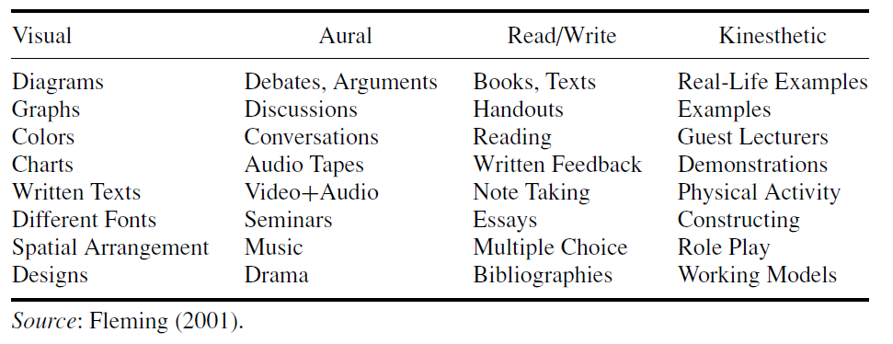**Figure 1:** Activities that accommodate VARK learning styles

The VARK model assesses an individual learning type based on a free questionnaire ([www.vark-learn.com](http://www.vark-learn.com)) that presents respondents with 13 statements describing a specific situation. The respondent then chooses from up to four different actions that are associated with each particular learning style of the VARK model and the results of the assessment indicate which learning styles the individual prefers (Fleming, 2001). Since the questionnaire allows for multiple styles to be chosen, a student’s preference of style may vary based on each individual situation, and there is no additional supporting research to show how valid or reliable the assessment is (Hawk, 2007).

**Felder–Silverman Learning/Teaching Style Model**

The Felder-Silverman Learning/Teaching style model (FSLSM), which has its origins in the field of engineering, defines learning style as “the characteristic strengths and preferences in the ways individuals take in and process information (Hawk 2007; Felder & Silverman, 1988, p. 674).” The model suggests that a student's personal learning preferences are set along five different bipolar continua which include two learning styles each: Active-Reflective, Sensing-Intuitive, Verbal-Visual, Sequential-Global, and Intuitive-Deductive (Felder, 1988). In addition to visual learning as described in the VARK model, FSLSM introduces seven other learning styles. An active learner will prefer doing things, most often in groups. A reflective learner chooses to work alone and ponder a specific task before performing it. A sensing learner prefers interpreting detailed facts and data. An intuiting learner enjoys being able to grasp new ideas and theories. Verbal learners prefer to hear information and discuss subject matter, particularly if it is heard in their own voice. A sequential learner will prefer learning things step-by-step with a steady stream of progressing material. Finally, global learners prefer to integrate and synthesize information in order to see the big picture (Hawk 2007).

Like the VARK model, the FSLSM is based on an assessment which can be self-administered via a questionnaire. The assessment includes 44 questions where two endings to a given sentence associated with a learning aspect may be chosen by the respondent (Hawk 2007). Scoring is based from 1 to 11, with 1-3 showing a balanced preference and 5-11 showing a moderate to strong preference (see Figure 2). While not every learning style referenced in FSLSM is directly related to a preference that can involve multimedia instruction, it does

**Figure 2:** Felder–Silverman learning style model.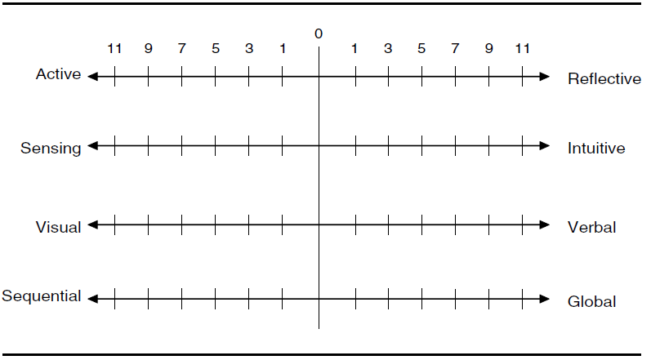

*Source: Hawk (2007, p. 8)*

illustrate how a student’s learning preference can be integrated with the cognitive process. For example, a visual learner who also leans toward sequential on the sequential-global scale, may prefer learning through a video that specifically presents information chapter by chapter, that also poses questions and concludes with a test for each. Additionally, a verbal learner who also leans toward the reflective end of the active-reflective scale and the global end of the sequential-global scale may choose to be presented with a program that allows them to think about what they learned, and provide examples on how it would apply to the overall scheme (Felder, 1988). Additional research is still needed in order to determine the validity, reliability and student performance based on the use of the FSLSM instrument (Hawk, 2007, p. 9).

**Designing an Effective Multimedia Experience**

With the recognition that an individual may prefer multiple learning styles based on the VARK model, comes the responsibility of solid design when building multimedia curriculum. For example, if a multimedia presentation focuses too much on special audio effects and music, the content of the details represented on the screen may be smothered and misunderstood, especially if the audio is only a narration of text that is already present. Additionally, a program should not be designed with so much visual content that it poses a distraction to the actual content of the presentation. One of the most crucial design aspects however, is designing a presentation that does not overload the student with information so as they cannot retain the essential message of a given lesson.

One of the primary theories in instructional design is known as Cognitive Load Theory. Cognitive Load Theory suggests that the capacity of a human’s working memory is limited (Sweller, 1998). In order for information presented in multimedia to be effectively retained by the learner, the demand on this memory must be reduced. A learner organizes information in knowledge that can be represented in long-term memory called schemas (Reiser, 2012). A schema places and categorizes information in a systematic way that is recognizable and predictable to the individual. (p. 37). For example, a person’s schema of the game of football may include the ball, the field, the rules, the players and teams that participate in the sport. One of the ways basic ways cognitive load can be reduced in multimedia is replacing text with narration when rich visuals may be present. This prevents the learner’s attention from being split between the two visual sources of text and pictures in a presentation (Mayer & Moreno 2003).

Some of the improved ways of designing effective multimedia programs for visual and auditory learners were addressed when Richard E. Mayer developed the Cognitive Theory of Multimedia Learning (CTML) (Mayer, 2005). Mayer based this theory on the primary components of Cognitive Load Theory. Mayer’s CTML included two specific principles intended to reduce the cognitive load known as the personalization effect and the voice effect (Günter 2013). The personalization effect suggests that students will have a better connection with the material when it is presented in a more personal and informal way as opposed to a formal or non-personalized fashion (Clark 2011). In a study conducted by Mayer, Fennell, Farmer, and Campbell (2004), students were given a lesson about the respiratory system. The speaker in one version used a personalized form using “you(r)” instead of articles; and a second version where associated formal forms were used (Mayer et al., 2004). The study revealed that students involved in the personalized version performed better in terms of information transfer as opposed to the formal version (Günter, 2013).

The second principle of CTML, voice effect, places more emphasis on knowledge retention. The voice effect states that students will retain information better when an audio narration is presented in a more familiar tone of voice, as opposed to a computer-based voice or foreign accent (Mayer & Sobko, 2003). Studies also suggest that students perform better when narration is presented in a dialect associated with their own region and ethnicity (Günter 2013). Therefore it would be critical when producing an e-learning module for long distance learning to take voice effect into consideration. For instance, if an audience uses English as a second language and Hindi as a primary, it may not be best to use a typical American accent for the presentation.

**Teaching the Teacher**

Incorporating multimedia based educational material in the classroom requires the instructor to use devices that are becoming more advanced every day. However, it is important that complexity doesn’t shift the focus of teachers away from instructing and towards simply learning how to use a device. Whether or not these devices will be used by the individual teacher is based on their willingness to accept these tools. A study was conducted by Roberto Aldunate and Miguel Nussbaum (2013), involving 100 teachers in a poor community in Chile. The study surveyed the teacher’s use of three advanced teaching devices, including an electronic whiteboard and digital camera. The results of the study revealed that teachers who were early adopters of technology and spent a majority of their time integrating this technology in their lessons were more likely to adopt newer and more complex technology (Aldunate & Nussbaum, 2013). However, the study also concluded that late adopters were more likely to abandon the technology, and that the lack of innovators and early adopters has a negative impact on the chances teachers will adopt new technology at all (p. 524). While the increased presence of newer technology and devices in the classroom may be unavoidable, it is important to consider their amount of use. If a teacher is unwilling to adapt to new technology, they may also be resistant to the use of more advanced multimedia.

**Conclusion**

The benefits of multimedia in the classroom can be enumerated and associated with specific learning styles. As more advanced technologies continue to arise, more critical studies may be required in the future to evaluate their advantages. Additional studies are needed to determine how the use of information technology affects existing curricula as well (Rodriguez, et al., 2011). With this in mind, it is imperative not to ignore the need for a presence of the instructor. Any gauged benefit to multimedia may fail if unsupported by a human element to analyze, evaluate and ultimately guide students in their use of multimedia.

The overwhelming use of technology in business and entertainment has compelled many other fields to use technology in order to be competitive and stand out amongst others. The same is true for education and the field of instructional design, however unlike commercial interests, it is more important to question the overall value of multimedia in schools and training environments. Though other research may suggest that the use of multimedia alone can enhance the learning experience, the presence of multimedia has blurred the line between what should be done, and what ought to be done when designing curriculum. Instructional design should be considered as a unique area when considering the incorporation of more advanced multimedia. As revealed with the comparisons of different learning styles, it would be beneficial to develop tests for a proposed lesson plan before integrating a program that relies heavily on multimedia to the point where it is less effective. The teacher also should be recognized as a more essential asset that cannot be replaced simply for the fact that human guidance must be present no matter how advanced technology may become.

**References**

Coffield, F., Moseley, D., Hall, E., Ecclestone, K. (2004). Learning styles and pedagogy in post-16 learning. A systematic and critical review. London: Learning and Skills Research Centre.

Clark R.C., Mayer R.E. (2011), E-learning and the science of instruction: Proven Guidelines for Consumers and Designers of Multimedia Learning (3rd ed.) Pfeiffer, A John Wiley & Sons Imprint, San Francisco, CA   
  
Curry, K. (2010). Warcraft and Civic Education: MMORPGs as Participatory Cultures and How Teachers Can Use Them to Improve Civic Education. Social Studies, 101(6), 250-253

Felder R.M., Silverman L.K. (1988), Learning and teaching styles in engineering education, Engineering Education, 78 (7), pp. 674–681

Fleming, N. D. (2001). Teaching and learning styles: VARK strategies.

Christchurch, New Zealand: N.D. Fleming.

Gibbon, Sam, Hooper, Kristina, (1986) Learning Tomorrow: Journal of the Apple Education Advisory Council, 3, p. 195-207

Günter Daniel Rey, Nadine Steib, (2013) The personalization effect in multimedia learning: The

influence of dialect, Computers in Human Behavior, Volume 29, Issue 5, September 2013, Pages 2022-2028, ISSN 0747-5632,

Hawk, Thomas F., & Shah, Amit J. (2007) "Using Learning Style Instruments to Enhance Student Learning" Decision Sciences Journal of Innovative Education

Mayer R.E., Fennell S., Farmer L., Campbell J. (2004), A personalization effect in multimedia learning: Students learn better when words are in conversational style rather than formal style, Journal of Educational Psychology, (96), pp. 389–395

Mayer, R.E., & Moreno, R. (2003) Nine ways to reduce cognitive load in multimedia learning.*Educational Psychologist*, 38(1), 43-52.

Mayer R.E., Sobko K., Mautone P.D., (2003) Social Cues in Multimedia Learning: Role of Speaker’s Voice. Journal of Educational Psychology, 95, pp. 419–425

Mayer R.E. (2005) Cognitive Theory of Multimedia Learning. Cambridge Handbook of Multimedia Learning, , pp. 31-48.

Ornstein, Allan C., (1991), Contemporary Education, , Vol.63(1), p.38-41

Pashler, H.; McDaniel, M.; Rohrer, D.; Bjork, R. (2008). "Learning styles: Concepts and evidence". Psychological Science in the Public Interest 9: 105–119.

Reiser, R. A., & Dempsey, J. V. (2012). *Trends and Issues in Instructional Design and Technology 3rd Edition.* Boston, MA: Pearson.

Roberto Aldunate, Miguel Nussbaum (2013), Teacher adoption of technology, Computers in Human Behavior, 29 (3), Pages 519-524,

Rodriguez, P., Nussbaum, M., & Dombrovskaia, L. (2011). Evolutionary development: A model for the design, implementation, and evaluation of ICT for education programmes. Journal of Computer Assisted Learning, 28(2), 81–98.

Sweller J., Van Merrienboer J.J.G., Paas F.G.W.C., (1998) Cognitive Architecture and Instructional Design Educational Psychology Review, 10 (3) , pp. 251-296.

VARK -- A Guide to Learning Styles. (n.d.). Retrieved from http://www.vark-learn.com